Bennettsbridge N.S.
Supporting your Child’s Learning

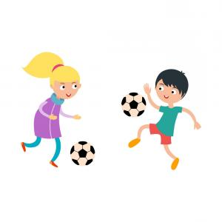
Fundamental Movement Skill: Kicking

Striking with the foot or kicking is a skill used in many sporting activities in Ireland. Kicking is a very useful tool to develop coordination between the foot and the eye. Activities that use the skill of kicking include rugby, soccer and Gaelic football. It is important when learning to kick that children try to kick as hard as they can.
Activities to try at home:
- Mark a target on an outside wall at home using chalk. Ask your child to kick a ball at the target. Every time the target is hit, encourage your child to take a step backwards and every time they miss, take a step forward.
- List five sports where kicking is important.
- Ask your child to kick with their non-dominant leg. Is it more difficult? Why? What can you do to make it easier?
- Search online for your child’s favourite footballer. Discuss the three things they notice about how they kick.

_________________________________
Class Teacher

