Bennettsbridge N.S.
Supporting your Child’s Learning
Fundamental Movement Skill: Balancing

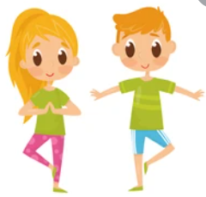

Balance is essential for all physical development and is a pre-requisite for almost every movement skill. It is sub-divided into two categories:
1. Static balance: the ability to maintain a static position throughout a movement (e.g. a handstand in gymnastics).
2. Dynamic balance: controlling the body when moving (e.g. keeping the body stable while kicking a football).
Watch the video clip demonstrating the skill of balancing. It shows the developmental stages that children go through on their journey to mastering the skill. Click on the link and scroll down to balancing.
https://www.scoilnet.ie/pdst/physlit/videos/
Activities to try at home:
- Jump, Land & Stick:
- Jump from one foot to one foot, land and hold your balance
- Jump from two feet to two feet, land and hold your balance
- Jump from one foot to two feet, land and hold your balance
- Jump from two feet to one foot, land and hold your balance
- Can you balance with your eyes closed, extend the length of your jump, jump forwards, jump left and right while maintaining your balance

- Choose a theme and design a movement and balance sequence and practise it at home with a family member eg. the circus: move like an elephant, hold a balance pretending to be a tightrope walker, walk on the tightrope, jump like a clown, hold a balance pretending to be an acrobat, hop and swing like a monkey and hold a balance pretending to be a juggler.

_______________________
Class Teacher

