Bennettsbridge N.S.
Supporting your Child’s Learning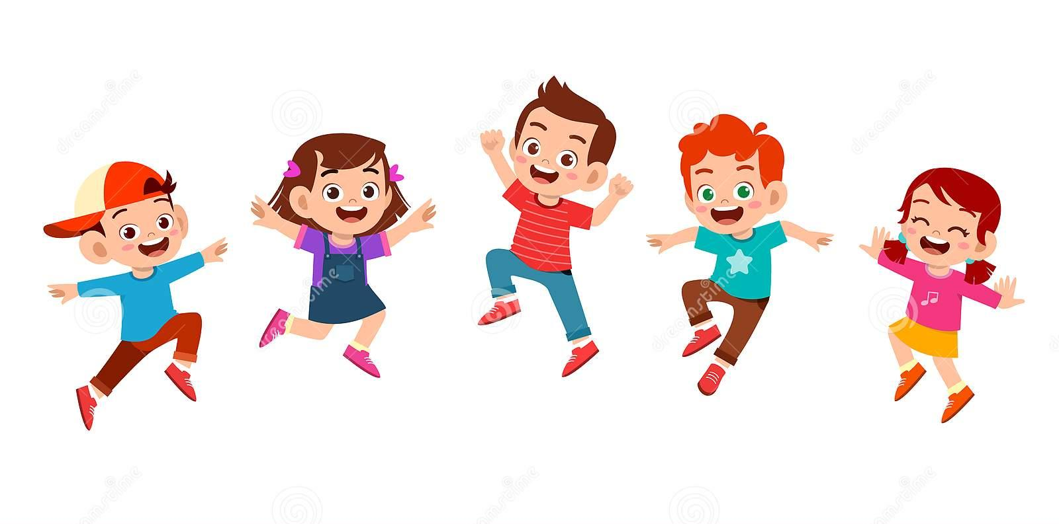
Fundamental Movement Skill: Jumping for Height
Jumping is the transfer of weight from one or two feet to two feet. Jumping for height involves jumping as high as possible from a standing position. To jump as high as possible it is important that the legs and arms work together. Jumping for height is important in a range of contexts, such as gymnastics, dance, jumping for a ball in volleyball, basketball and Gaelic football or attempting to get something down from the top shelf.

Watch the video clip demonstrating the skill of jumping for height. It shows the developmental stages that children go through on their journey to mastering the skill. Click on the link and scroll down to jumping for height.
https://www.scoilnet.ie/pdst/physlit/videos/
Activities to try at home:
- Pillow high jump Place one pillow on the ground and attempt to jump over the pillow. Each time you successfully jump over the pillow, add another pillow on top of the stack. How many pillows can you jump over? Invite a family member to play pillow high jump with you
- Bottle flip jump Tie one end of a skipping rope/ ribbon/ tights around a bottle. Tie the other end of the rope around your waist. Start with the bottle on its side on the ground. Jump for height and attempt to get the bottle to stand

- Home Activity A Begin with arms behind the body. Keep head up and eyes looking forward. https://vimeo.com/445498841

Home Activity B Straighten and extend arms and legs when in the air. Bend ankles, knees and legs when landing. https://vimeo.com/445498843

Home Activity C Land on both feet https://vimeo.com/445498842

___________________
Class Teacher

