Bennettsbridge N.S.
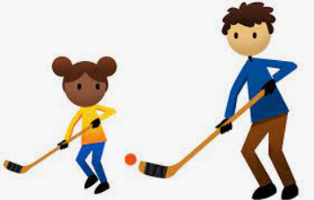
Supporting your Child’s Learning
Fundamental Movement Skill: Striking with an implement
Striking with an Implement (also referred to as the two handed strike) involves applying force to an object using an implement. This striking action is found in many sporting contexts such as tennis, hurling, rounders, hockey and golf. Striking a stationary object can be very useful when exposing pupils to striking with an implement.

Watch the video clip demonstrating the skill of striking with an implement. It shows the developmental stages that children go through on their journey to mastering the skill. Click on the link and scroll down to striking with an implement.
https://www.scoilnet.ie/pdst/physlit/videos/
Activities to try at home:
- Balance a ball on a bat or any other implement and object. Maintain control of the object while carrying out some of the following instructions:
- jump with feet together/feet apart
- stand on one leg/on tippy toes
- hold the racket in one hand and rub your head with the other
- toss the ball in the air and catch it in your hand/racket

- Design an obstacle course that includes dribbling a ball around the course. Use a hurley or other implement at home. Why not give it a go. Invite a friend or family member to design it with you. Also, include one or more of the following;
- Striking to a target
- Striking to a partner
- Striking through a goal

_______________________
Class Teacher

