Bennettsbridge N.S.

Special Education Needs Policy

1. Context

Bennettsbridge N.S. is a co-educational, mainstream, vertical primary school catering for children from mixed social and cultural backgrounds. The purpose of this policy is to provide practical guidance for teachers and parents and other interested parties on the provision of effective learning support to pupils experiencing low achievement and/or learning difficulties, as well as to fulfil our obligations under the Education Act 1998.

As of 23/24, the school has the following provisions to cater for children with Special Education Needs: ( 60 Hours)

- Two full-time Special Education Teachers

- One part-time Special Education Teacher (10 hours)

- One part-time English as an Additional language Teacher (15 hours)

- Aims of SEN Support

Our school is committed to helping our pupils to achieve their full potential. The principal aim of Special Education Teaching is to optimise the teaching and learning process in order to enable pupils with special educational needs to achieve adequate levels of proficiency in literacy and numeracy before leaving primary school. The provision of a quality system of SEN support teaching is integral to this commitment. Through the implementation of our SEN policy, we aim to:

  - Support the inclusion of children with SEN in our school through enabling children with special educational needs to join in school activities along with children who do not have special educational needs
  - Develop positive self-esteem and positive attitudes about school and learning in pupils
  - Ensure that the Staged Approach/Continuum of Support is implemented (see below)
  - Ensure that our duties, as set out in The Education Act 1998, Equal Status Act 2000,

Education Welfare Act 2000 and Education for Persons with Disabilities Act 2004 are fully met
- Ensure that all children gain access to a broad and balanced curriculum, to participate in the full curriculum of their class and have an equal opportunity to receive an education that is appropriate to their needs
- Identify and assess children with special needs as early as possible
- Establish early intervention programmes designed to enhance learning and to prevent / reduce difficulties in learning
- Support children’s development both socially and emotionally
- Promote collaboration among teachers in the implementation of whole-school policies on learning support for our pupils
- Ensure that the child’s special educational needs will be overcome in as short a time as possible
- Use our resources as efficiently and equitably as possible when assessing and meeting the special educational needs of our children
- Develop a partnership with parents/ carers in order that their knowledge, views and experience can assist us in assessing and providing for their children
- Take into account the ascertainable wishes of the children concerned and, whenever possible, directly involve them in decision making in order to provide more effectively for them
- Ensure collaboration with the DES in order to take effective action on behalf of children with special needs
- Monitor our effectiveness in achieving the above objectives (through regular staff reflection and SSE)
3. Principles of SEN Support

All our children have a right to an education which is appropriate to them as individuals. We want all our children to feel that they are a valued part of our school community. As far as possible, therefore, it is our aim to minimise the difficulties that children may experience. We aim to achieve this by adopting principles that are essential to developing a more inclusive curriculum.

The provision of SEN support in our school is based on the following principles:
- Quality of teaching.
- Effective whole-school policies.
- Direction of resources towards children in greatest need.
- Implementation of a staged approach to support provision at Class Support/School Support/School Support Plus levels.
- Provision of the model(s) of intervention appropriate for the child, including a block of support for a specified period, the withdrawal model, in-class support model, individual or group work, etc.
- Provision of effective early identification of additional learning needs followed by intensive, early intervention.
- Setting suitable learning challenges: We aim to give every child the opportunity to experience success in learning and to achieve as high a standard as possible
- Responding to children’s diverse learning needs: We take into account the different backgrounds, experiences, interests and strengths that influence the way in which children learn when we plan our approaches to teaching and learning
- Overcoming potential barriers to learning and assessment for individuals and groups of children: We recognise that a minority of children will have particular learning and assessment requirements that will create barriers to learning if we do not address them through special arrangements and accommodations.
Three Stage Approach to SEN

At BBNS we have adopted the three-stage approach to SEN and Learning Support, as specified in the DES publication Special Education Needs: A Continuum of Support (Guidelines for Teachers).

Stage 1: Classroom Support
- Classroom Support is the most common, and typically the first response to emerging needs. It is a response for pupils who have distinct or individual educational needs and who require approaches to learning and/or behaviour which are additional to or different from those required by other pupils in their class.
- Problem solving at this level typically begins when a parent or class teacher has concerns about an individual pupil. The class teacher and parents discuss the nature of the problem and consider
strategies which may be effective. Classroom Support incorporates the simple, informal problem-

solving approaches commonly used by class teachers to support emerging needs.
- Time-bound targets are agreed (typically six weeks), implemented and reviewed after this time.
- A pupil receiving support within their classroom would be considered to be at Stage 1 in terms of the "Staged Approach to Assessment, Identification and Programme Planning"

Stage 2: School Support
- In some cases, interventions at classroom support level are not enough to fully meet the pupil’s special educational needs. School Support may, therefore, be required.
- The class teacher needs to involve the Special Education Team in the problem-solving process at this point and it involves more systematic gathering of information and the development and monitoring of a School Support Plan.
- A pupil receiving group or individual support in addition to classroom support would be considered to be at Stage 2 in terms of the "Staged Approach to Assessment Identification and Programme Planning"

Stage 3: School Support Plus
- If a pupil’s special educational needs are severe and/or persistent, they are likely to need intensive support. School Support Plus will generally involve personnel outside the school team in the problem solving, assessment and intervention process.
- A pupil receiving more intensive teaching support including more focused and regular small group work or individual teaching is considered to be at Stage 3 in terms of the "Staged Approach to Assessment Identification and Programme Planning".

“Interventions with children at stages 2 and 3 should include a classroom support plan to ensure that the children’s needs are met for the whole school day” (Guidelines 2017 p7)

4. Roles and Responsibilities

The role of supporting learning is a collaborative responsibility shared by all the school community. The Board of Management, Principal Teacher, Parents, Class Teachers, Special Education Team, SNAs, Children and external bodies and agencies will take all reasonable steps within the limits of the resources available to fulfil the requirements outlined in this policy document.
Board of Management

The Board of Management will:

- Fulfil its statutory duties towards pupils with special needs
- Oversee the development, implementation and review of the provision of SEN support in the school
- Be informed of the reviewed SEN policy and any updates to it.
- Ratify the SEN policy.
- Ensure that satisfactory classroom accommodation and teaching resources are available for SEN pupils
- Provide secure facilities for the storage of records relating to children in receipt of SEN support
- Budget for ongoing support for Professional Development in the area of SEN for staff.

Principal Teacher

The Principal has overall responsibility for the day- to- day management of provision for children with SEN. Part of this work ensures that the class teachers, SET Team and parents of SEN pupils are enabled to fulfil their roles as outlined in the school plan. The Principal will work closely with the SET Team and will keep the BOM informed about the working of this policy. They will encourage members of staff to participate in training to help them meet the objectives of this policy. In consultation with the SET Team, they will liaise with the SENO and is responsible for Special Education staff allocation. They will monitor the implementation of the school plan on Special Education Teaching on an ongoing basis. They will also monitor the selection of pupils for supplementary teaching, ensuring that children with the greatest need are prioritized for additional support and intervention.

Class Teacher

The Class Teacher has primary responsibility for the progress of all children in his/her class, including those selected for supplementary teaching. (Guidelines 2017)
The Class Teacher will:
- Provide effective teaching and learning opportunities for all pupils in accordance with their ability and learning style
- Support the identification of learning difficulties and record same through teacher observation
- Access relevant information from previous class teacher
- Record actions in the pupils log of actions
- Communicate effectively and positively with parents/guardians
- Draw up, implement and review Classroom Support Plans (Stage 1 Continuum of Support)

A key element of successful SET intervention is a very high level of consultation and co-operation between the Class Teacher and SET Team. The Class Teacher will:

- Collaborate with the SET Team in the development of a Support Plan for each child who is in receipt of supplementary teaching at School Support/School Support Plus Level on the Continuum, by identifying appropriate learning targets and by organising classroom activities to achieve those targets
- Administer and score appropriate screening measures, and discuss the outcomes with the SET teacher.
- Discuss test results
- Collaborate with SET teacher on selection of pupils for additional support
- Provide and inform SET teacher of whole class schemes of work and targets in order for SET teacher to adequately plan, differentiate and prioritise pupil targets.

In the case of each pupil who has been identified as experiencing low achievement and / or a learning difficulty following administration of an appropriate screening measure, and in need of SET intervention, the class teacher should:

- Make parents aware of the concerns of the school about their child’s progress
- Outline to parents the support that is available in the school to pupils who experience low achievement and/or learning difficulties
- Indicate to the pupil’s parents that a meeting with the SET Team will occur
- Review outcome of assessments and discuss type of joint intervention with the SET Team
Monitor and review pupils’ progress with the SET Team

Special Education Team

The central roles of the SET Team will be to

- support the class teacher in optimising teaching and learning opportunities
- provide specialised teaching to those children with identified special educational needs.

Special Education Teacher responsibilities will consist of both teaching and non-teaching duties. These will include:
- Developing a support plan for each child who is in receipt of SET support, in consultation with the class teacher and parents and involving the voice of the pupil in devising their own targets/plan.
- Providing supplementary teaching commensurate with the child’s particular and individual needs, including EAL
- Researching the pupil’s specific learning difficulty, to become familiar with their needs and their preferred learning methods.
- Assessing their pupils on an on-going basis, and record their progress.
- Maintaining confidential records on each of his/her pupils
- Meeting with parents of each pupil who is in receipt of SET support to discuss targets and ways in which attainment of the targets can be supported at home
- Providing advice to class teachers in such areas as individual pupil assessment, programme planning, differentiation of the curriculum, as well as approaches to language development, English as an additional language, literacy, numeracy, social, emotional and behavioural difficulties or pupils in receipt of additional support
- Maintaining and reviewing pupil records regularly and recording actions in the pupils log of actions.
- Familiarising themselves with a wide range of teaching approaches, methodologies and resources to cater for particular learning styles and to meet a variety of needs (Guidelines 2017 p.13).
- Prioritising relevant continuous professional development to best meet the needs of pupils on their caseload and to communicate information to class teachers, SNAs and parents.
- Maintaining a Short-Term Plan (weekly) and Progress Record, or equivalent, for each individual or group of children accessing support
- Administering a range of formal and informal assessments
- Contributing to the delivery of intensive early intervention programmes. (e.g., Literacy Lift Off, Mata sa Rang/Maths Stations, Junior Speech and Language programmes, phonics & sight word programme, phonological awareness etc)
- Contributing to the development, regular review and update of SEN policy.
- Compiling PPP’s and SNA timetable for children in receipt of SNA provision (SENCO)
- Completing necessary referral forms for outside agencies in collaboration with the class teacher, parents and relevant staff
- Work closely with class teachers to screen pupils for learning difficulties and interpret the outcomes of diagnostic assessments.
- Co-ordinating the implementation of whole-school procedures for the selection of pupils for supplementary teaching, giving due consideration to:
✔ The selection criteria specified in this SEN Policy
✔ Teachers’ professional observations
✔ Input from parents
- Carrying out a comprehensive diagnostic assessment of each pupil who has been identified as experiencing low achievement and/or learning difficulties
- Collaborating with the principal teacher and meet with them regularly to discuss issues relating to the development and provision of SET Support, including SNA access and provision
- Gathering teacher observations and presenting to NEPS psychologist during the first term
- Referring pupils for additional assessment and support when deemed necessary e.g., psychological, speech and language therapy, occupational therapy.
- Liaising with and implementing recommendations from outside agencies, wherever possible
- Researching and purchasing learning resources, books and materials to be made available to pupils with learning difficulties and their teachers
- Ensuring that the school’s assessment resources are up to date and in line with best practice
- Timetabling of pupils for supplementary teaching ensuring that pupils with the greatest need are prioritised regardless of having a formal diagnosis/assessment.

The Principal, SENCO and SET Team will share responsibility for:
- Overseeing the day-to-day operation of the SEN policy
- Coordinating provision for children with special educational needs
- Liaising with and advising fellow teachers and contributing to in service training of staff
- Liaising with and advising SNAs with regard to supporting children with special needs
- Liaising with parents of children with special needs
- Monitoring and evaluating SEN provision
- Facilitating planning for class teacher with SET team
- Overseeing the records of all children with special needs
- Liaising with external agencies
Role of SNA

The role of an SNA will be to carry out duties based on the care needs of the child. BBNS encourages close collaboration between Principal, SET team, SNAs, parents and the individual child to best meet the pupil’s care needs. The tasks associated with these duties can be of a primary or secondary nature. (Circular 0030/2014)

Primary care support tasks may include:
- Administration of medicine.
- Assistance with toileting and general hygiene.
- Assistance with mobility and orientation.
- Assisting teachers to provide supervision in the class, playground and school grounds, and at recreation, assembly and dispersal times.
- Assisting children while at play as appropriate.
- Provision of non-nursing care needs associated with specific medical conditions.
- Care needs requiring frequent interventions including withdrawal of a child from a classroom when essential.
- Assistance with moving and lifting of children, operation of hoists and equipment.
- Assistance with severe communication difficulties including enabling curriculum access for children with physical disabilities or sensory needs and those with significant, and identified social and emotional difficulties.

The secondary care support tasks may include:

- Preparation and tidying of workspaces and classrooms or assisting a child who is not physically able to perform such tasks; to prepare and tidy a workspace, to present materials, to display work, or to transition from one lesson activity to another.
- Assistance with the development of Personal Pupil Plans (PPP) for children with Special Educational Needs, with a particular focus on developing a care plan to meet the care needs of the child concerned and the review of such plans.
- Assistance with maintaining a journal and care monitoring system for children including details of attendance and care needs.
- Planning for activities and classes where there may be additional care requirements associated with particular activities.
- Attending meetings with Parents, Special Educational Needs Co-ordinator (SENO); National Educational Psychological Service (NEPS); or school staff meetings with the agreement and guidance of Class Teacher/Principal.
- Assistance with enabling a child to access therapy or psycho-educational programmes such as anger management or social skills classes, under the direction of appropriate personnel.
- Assistance to attend or participate in out of school activities: walks, or visits, where such assistance
cannot be provided by teaching staff.
Role of Parents/Guardians

BBNS recognises parents/guardians as the primary educators of their child and thus parents play a central and significant role in planning provision of support for their child with additional needs. Their role is to support the work of the school and to optimise teaching and learning opportunities for their child at home. The parent should maintain regular communication with the Class Teacher and Special Education Teacher. BBNS endeavours to provide an ‘open door’ policy which welcomes parents’ regular and meaningful collaboration and input in their child’s support plan/personal pupil plan. Parents will be consulted at a minimum 3 times annually to plan and review their child’s support.
Role of Children

The role of the child with SEN will be that of an active participant in their own learning; the extent and nature of this will depend on their strengths and needs. BBNS recognises the importance of including the voice of the child in planning their own learning and targets.
Role of External Bodies and Agencies

Our school liaises with external professionals such as NEPS Psychologists, Special Education Needs Organisers (SENO), the National Council for Special Education (NCSE) Support Service, the HSE
(Health Service Executive), OIDE, Children’s Disability Network Teams (CDNT). Primary Care, private consultants and practitioners, occupational therapists, speech and language therapists, Enable Ireland, Tusla, Visiting Teachers for children with hearing impairment, and the Inspectorate. We acknowledge that the needs of many children span both health and education services. We therefore liaise with relevant external professionals to plan the provision of appropriate and recommended interventions and facilitate meetings between parents and various support services. We also endeavour to incorporate relevant recommendations from health and education professionals in developing support plans at each level of the Continuum of Support.

- Prevention and Early Intervention Strategies

  - Development and implementation of agreed approaches to the teaching of Literacy and Numeracy to ensure progression and continuity from class to class, including the Aistear programme in the Infant classes ,Literacy Lift Off Guided Reading using the PM Readers in Senior Infants, First Class and Second Class, Maths Stations and Jolly Phonics programme.
  - Differentiation of the curriculum by the mainstream class teacher to cater for individual strengths and needs encompassing a variety of approaches to differing learning styles
  - Careful development of phonological awareness, rhyming skills and oral language skills, before formal reading of words and books.
  - The use of concrete materials as much as possible and as appropriate.
  - Ongoing structured observation and assessment of the language, literacy and numeracy skills children in the Infant classes to facilitate early identification of possible learning difficulties. (Bellfield Infant Assessment Profiles (B.I.A.P) administered to pupils of concern in term 3 of Junior Infants, Middle Infant Screening Test (M.I.S.T) administered in February to pupils in Senior Infants. Jolly Phonics Reading Assessment will be administered bi-annually at the end of Term 1 and Term 3 in Junior and Senior infants, Drumcondra Early Literacy and Numeracy whole class screening administered in Term 3 of Senior Infants followed by diagnostic assessment for pupils of concern.
  - Class-based early intervention by the class teacher focusing on the provision of additional individualised support, as and when required.
  - Provision of additional support in language development/early literacy/early mathematical skills to children who need it.
  - Support for children experiencing social/emotional difficulties and problems with concentration.
  - Provision of Assistive Technology as appropriate.
  - Promotion of parental/guardian involvement through their attendance at induction meetings for incoming Junior Infants and the arrangement of formal and informal parent/teacher meetings and email/phone contact.
  - Collaboration and consultation between the Class Teachers and the SET Team should identify children who may be in need of early intervention. Teacher observation and professional opinion will be given due consideration in the selection of children for early intervention programmes at Classroom Support/School Support level.
  - Ability assessment administered annually in 2nd, 3rd and 4th classes (Non-Verbal Reasoning Test (NVRT), New Non-Reading Intelligence Test (NNRIT)) to identify any possible learning difficulties when analysed alongside literacy/numeracy standardised test results
  - Drumcondra Spelling administered to all of 5th class annually and other pupils of concern from 2nd class upwards.

6. Identifying and selecting children for additional teaching support

*Key premise in BBNS*
Children with the greatest level of need have access to the greatest level of supports.

BBNS adopt the following approach in identifying and selecting children for additional teaching support. (Guidelines for Primary Schools: Supporting Pupils with Special Educational Needs in Mainstream Schools- 2020, p.19/20)
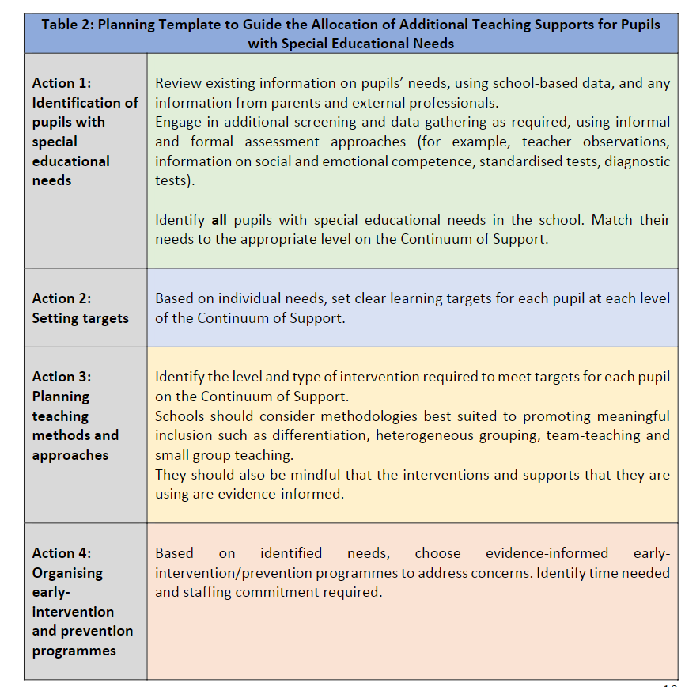
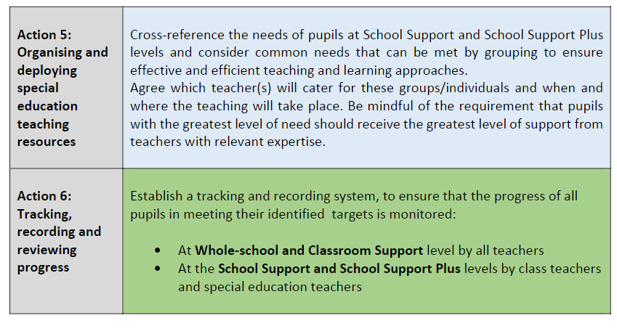
Criteria for selection of children for additional teaching support
- Children deemed School Support Plus pupils with complex, significant and enduring needs with or without a formal diagnosis/assessment.
- Early intervention: Children who continue to experience difficulties in Literacy, Numeracy, Oral language, Listening Skills, Social, emotional, behavioural and attention despite classroom-based intervention.
- English as an additional language: Pupils assessed using the Primary School Assessment Kit in line with European standards and supported according to their needs/abilities
- Children scoring below the 10th percentile in Literacy and / or Numeracy.
- Children scoring at or below the 20th percentile in Literacy and / or Numeracy.
- Children scoring at or below the 30th percentile in Literacy and / or Numeracy.
- Children who having received classroom support continue to experience difficulty either physically, with Social/emotional/behavioural issues, application to learning or Oral Language delay. Teacher observations are crucial here.
- Children scoring at or below the 40th percentile in Literacy and / or Numeracy, if caseload/timetable allows
- Transition to Post Primary: A programme will be put into place for those in 6th class requiring support. (Usually in the summer term)
- Exceptionally able children. Support from CTYI is accessed if parent led.

* Procedures for New Pupils to the School
- Information from previous school
- Liaising with parents
- Gathering of any relevant reports/information from external professionals
- Where the pupil has been already receiving SET support our SET Team will contact the pupil’s previous SET Team.
- Teacher observation
- Additional screening of pupil if and when appropriate (following a settling in period)
- Continuing and Discontinuing Supplementary Teaching.

  - At the end of each instructional block/term the progress and targets of each child who is in receipt of support teaching will be evaluated following consultation with the child’s class teacher and where appropriate, the child’s parents/guardians and the child themselves.
  - A decision will be made regarding their continued level of support and revised targets will be set in their Support Plan, if needed.
  - The school may decide to discontinue supplementary teaching with some children where the targets have been met and the pupil (on assessment) has made sufficient progress to warrant a return to normal classroom routine. The child’s parents are informed via phone call, meeting or email and will be contacted again if further intervention is required. and a
  - The school may also decide to discontinue supplementary teaching with some children who are now performing above the percentile laid down in the selection criteria for receiving support; however, if both the class teacher and support teacher feel such a child needs scaffolding to maintain this standard then continued supplementary teaching may be offered if places are available in the appropriate group.
  - Due consideration will be given to the overall needs of the school and all of its pupils, always ensuring those with the greatest need receive the greatest level of support.

7. Monitoring Progress

- The Support Review Record on the Continuum of Support will be completed by the SET Teacher in collaboration with the Class Teacher, parents and pupil. This will be carried out at the end of each instructional period, generally February and June. The completed review will be saved in Aladdin (our school Administration System).
- Regular Self-Reflection (by the child) – as part of the Continuum of Support Review Record
- Weekly Tests (if applicable)
- Teacher observations, frequency charts etc
- A range of formal and informal assessments
- Termly Assessments if applicable (teacher designed or from publishers).
- Standardised Tests at end of year (1st – 6th) English and Maths. (Drumcondra Literacy and Drumcondra Numeracy)
- Bellfield Infant Assessment Profiles (B.I.A.P) administered to pupils of concern in term 3 of Junior Infants
- Senior Infant- February–Middle Infant Screening Test (M.I.S.T)
- Jolly Phonics Reading Assessment will be administered bi-annually at the end of Term 1 and Term 3 in Junior and Senior infants
- Drumcondra Early Literacy and Numeracy whole class screening administered in Term 3 of Senior Infants followed by diagnostic assessment for pupils of concern
- Ongoing structured observation and assessment of the language, literacy and numeracy skills of the children in the Infant classes to facilitate early identification of possible learning difficulties
- Record Keeping

  - Classroom: Class Teachers will keep a record of teacher designed tests, end of term tests and checklists in an Assessment Folder for their class.
  - SET Room Filing cabinet (locked): Continuum of Support documents, Personal Pupil Plans (for children with SNA access), psychological Reports, reports from external agencies, diagnostic Assessments, work samples and other checklists administered by the Support Teacher will be put in the child’s file in the SET Room and also uploaded to Aladdin where applicable.
  - Secretary’s office filing cabinet (locked): Results of Completed Standardised Tests will be uploaded to Aladdin and a copy of each will be filed in the Pupil folders in the office. The class-based Standardised Tests currently used in our school are – MIST (Senior Infant Test), Drumcondra early Literacy and early Numeracy(Senior Infants) Drumcondra Literacy and Numeracy (First Class – sixth class), Non-verbal Reasoning Test (NVRT) (2nd & 4th), New Non-Reading Intelligence Test (NNRIT) (3rd ), Drumcondra Spelling (5th Class)
  - End of Year school Report will be issued to parents/guardians in June. Individualised report cards may be used for children with complex needs or EAL needs. All end of year reports are saved on Aladdin.
  - Monthly Reports from the SET Team will be saved on a shared drive within our secure School Workspace. These reports outline the work undertaken by the support Teacher with groups or individual children.
  - SET Timetable, Weekly Planning and Progress Records will be stored in individual SET folders.

- Liaising with Parents/Communicating Information

Effective communication with parents is critically important to the success of a SET programme. Teachers will take every opportunity to make parents familiar with the purpose and procedures of their child’s Support Plan. Teachers will demonstrate techniques and strategies and advise parents on ways that will enable them to help with their child’s development in such areas as oral language, reading, writing, spelling and mathematics at home.

- Class teacher meets with parents/guardians initially to discuss concerns and outline supports available in the school. (Classroom Support Stage)

- SET teacher and Class Teacher meet with parents to agree a School Support Plan for the child.
- SET Teacher liaises with parents of children in receipt of supplementary teaching to demonstrate methodologies that could be useful at home to further the child’s learning.
- Parents are encouraged and supported to become involved in their child’s learning.
- Parent Teacher Meetings are usually held in November and when required throughout the school year particularly for support plan reviews and target setting.
- An information meeting is held for the parents of incoming Junior Infants in June.
- An end-of-year report goes home in June each year. Opportunities to discuss this report are made available before the end of term
- A designated SET email setbennettsbridgens@gmail.com is provided to parents to communicate directly with the SET team.

- Timetabling
  - Supplementary teaching that children receive is in addition to their regular class programme in English and Maths, insofar as is practicable.
  - Co-teaching, where two teachers work together to plan, organise, instruct and make assessments on the same group of students, sharing the same classroom can operate during English and Maths times in class. If deemed more beneficial to the group being taught by the Support Teacher, they can be withdrawn to a quiet space.
  - In so far as is practicable children should not miss out on the same curricular area each time they receive supplementary teaching.
  - The Support Teaching Team will review the timetable at the end of each instructional term/block
12. Attendance
An attendance record of children who are withdrawn to the SEN rooms will be kept by each Support Teacher.
13.Monitoring and Reviewing the SEN Policy
This policy will be monitored and reviewed as warranted.
- SEN Policy Success Criteria

A whole school approach to the implementation of our SEN policy will:
  - Ensure that children with SEN gain access to a broad, balanced curriculum and have opportunity of access to an appropriate education.
  - Develop positive self-esteem and positive attitudes to school and learning among our pupils.
  - Improve standards of academic performance and achievement.
  - Enhance parental involvement in supporting their child’s learning.
  - Increase collaboration between school personnel.
  - Ensure the wellbeing of our pupils is central and all planning and provision should respect and encourage positive wellbeing.
  - The achievement of these success criteria will be assessed through: feedback from teachers, children and parents/guardians; child’s achievements and ongoing analysis of children’s academic performance and attainment of personal targets.
Ratification

This policy was reviewed and ratified on 25th May 2021.

Signed: Chairperson,
Bennettsbridge N.S. , Board of Management.

Appendix 1: Formal Assessments used in SET:

- Wide Range Achievement Test (WRAT)
- Wechsler Individual Achievement Test (WIAT)
- GL Assessment Dyslexia Portfolio
- Non-Verbal Reasoning Test (NVRT)
- New Non-Reading Intelligence Test (NNRIT)
- Verbal Reasoning Test (VRT)
- MICRA (old) Literacy
- SIGMA (old) Numeracy
- New Group Reading Test (NGRT)
- Drumcondra Early Literacy (Screening and Diagnostic)
- Drumcondra Early Numeracy (Screening and Diagnostic)
- Drumcondra Spelling
- Drumcondra Literacy
- Drumcondra Numeracy
- Neale Analysis of Reading Ability
- York Assessment of Reading for Comprehension (YARC)
- Bellfied Infant Assessment Test (BIAP)
- Middle Infant Screening Test (MIST)
- Trinity Early Screening Test for Reading and Writing (TEST2r)
- Mathematics assessment for learning and teaching (MALT)

